
800 Eighth Street
Vero Beach, FL 32962
O-772.562.0018 F-772.563.0065 C-772.473.0018

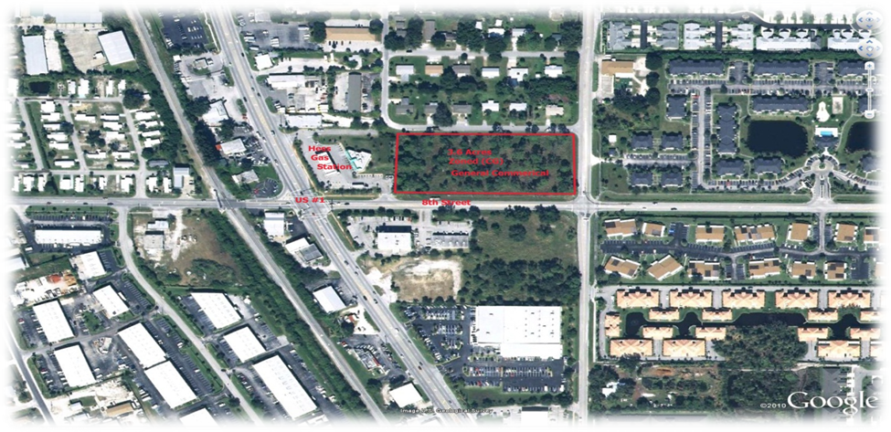
Location: US #1 & Eighth Street (on the east side of US #1)
Vero Beach, Florida 32962

Price: $1,400,000

Size: 3.6 Acres - 156,816 SF Utilities: Water & Sewer Available

Zoning: General Commercial R Estate Taxes: $7,525 / 2010

Owner financing / Owner will subdivide

Property Description

This lot is adjacent to Hess Gas Station and has extremely high traffic count. Also has an exit on to US #1 on the North side. This lot is ideal for retail, restaurant, medical and business office. This lot on the east side has a corner on 8th Street & 6th Avenue.

